NAME: Harshit Deepak Kadam
AF Code: AF05047333

Create Employees (EmployeeID, Name, Age, Salary,Department) and give autoincremented value to id and salary should be in decimal.
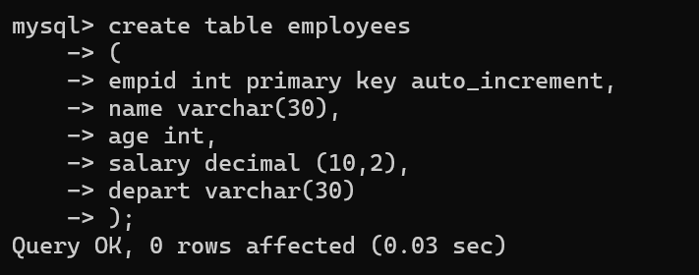

Q.2) Insert minimum 15 records.

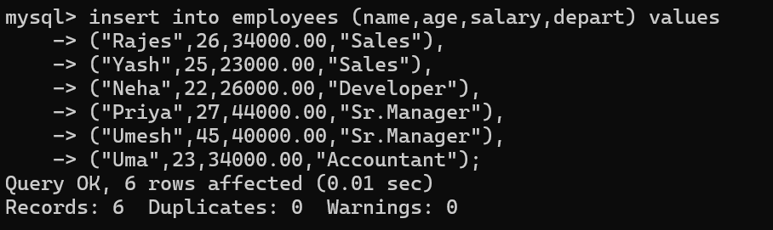
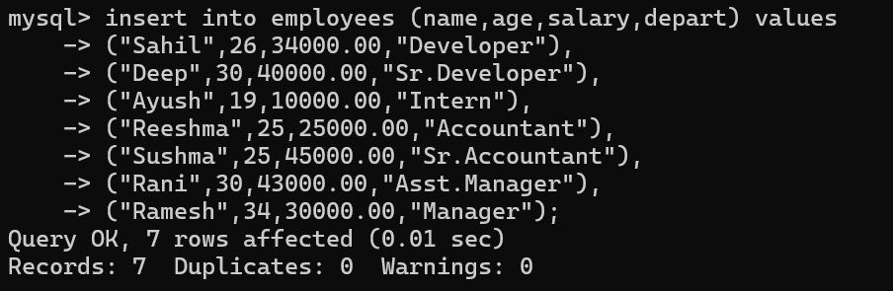

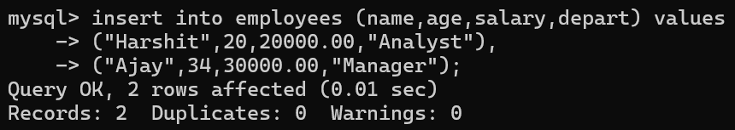
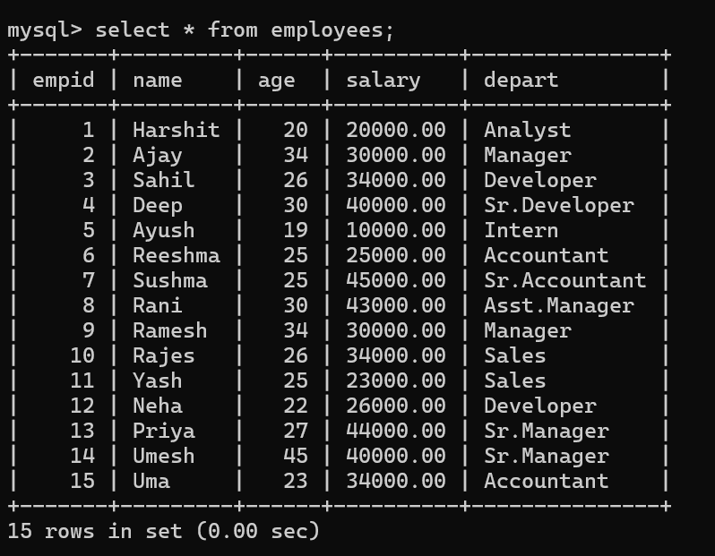

Q.3)Update salary of person whose salary is less than 30000

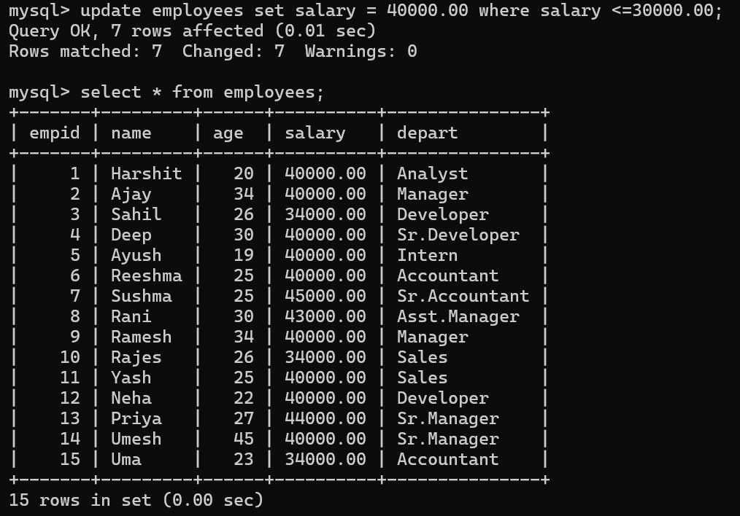

Q.4)Delete all the records whose salary is less than 15000.

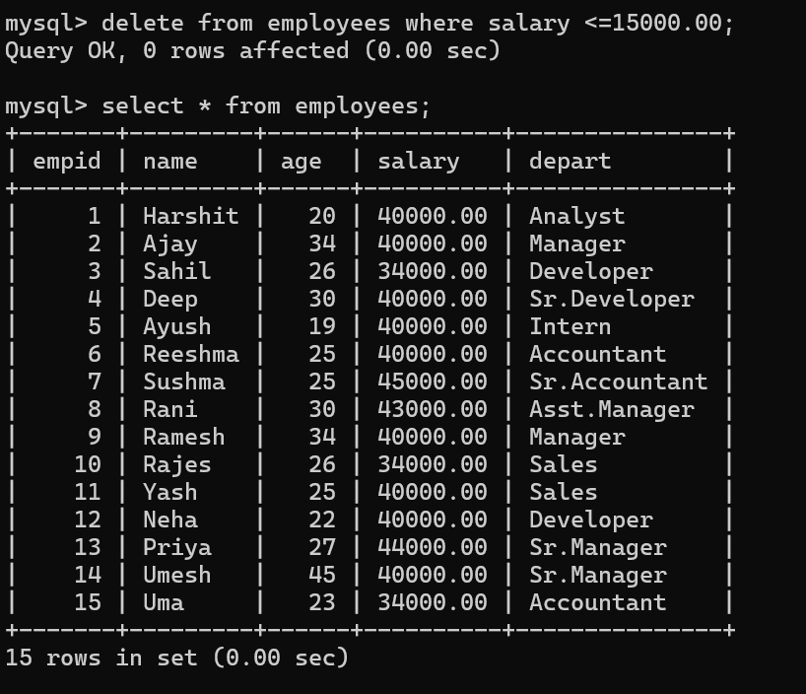

Q.5)Delete a record whose id=13

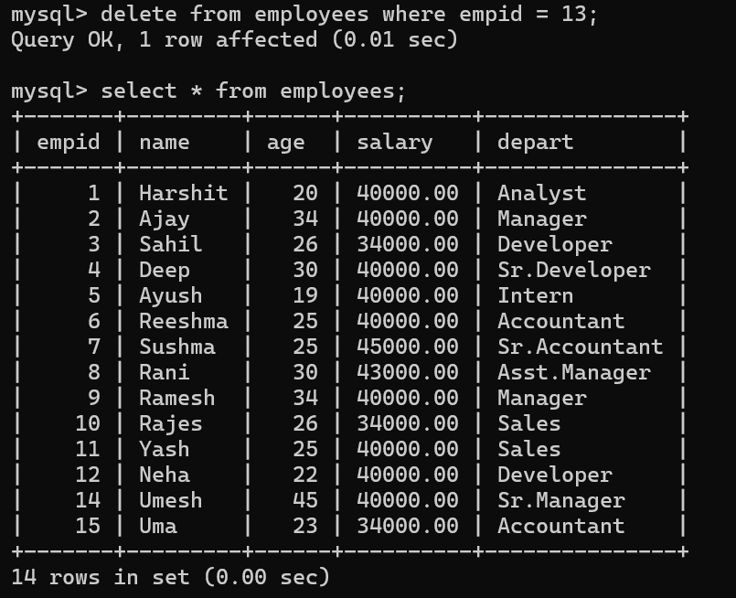

Q.6)Find Maximum salary department wise.

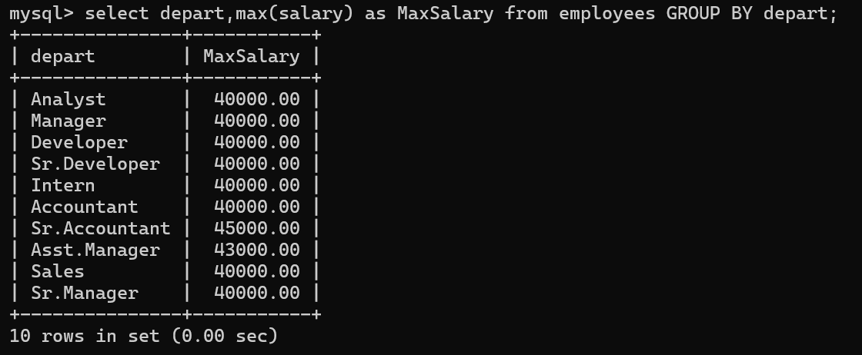

Q.7)Find average salary of a person in company.
